James Naurot

John Wangari

Assignment #5

In this assignment, John and James worked together to implement the code the Professor provided. John was primarily responsible for the Decorator classes and James was primarily responsible for the Tax Computation. James looked up the current dates for the “tax holidays” for Massachusetts and Maryland (2020). We communicated/collaborated heavily on the rest of the program.

Store information is in store.cfg

Items are in storeitems.dat

Now for a tour of the program:

On start up, a date prompt appears

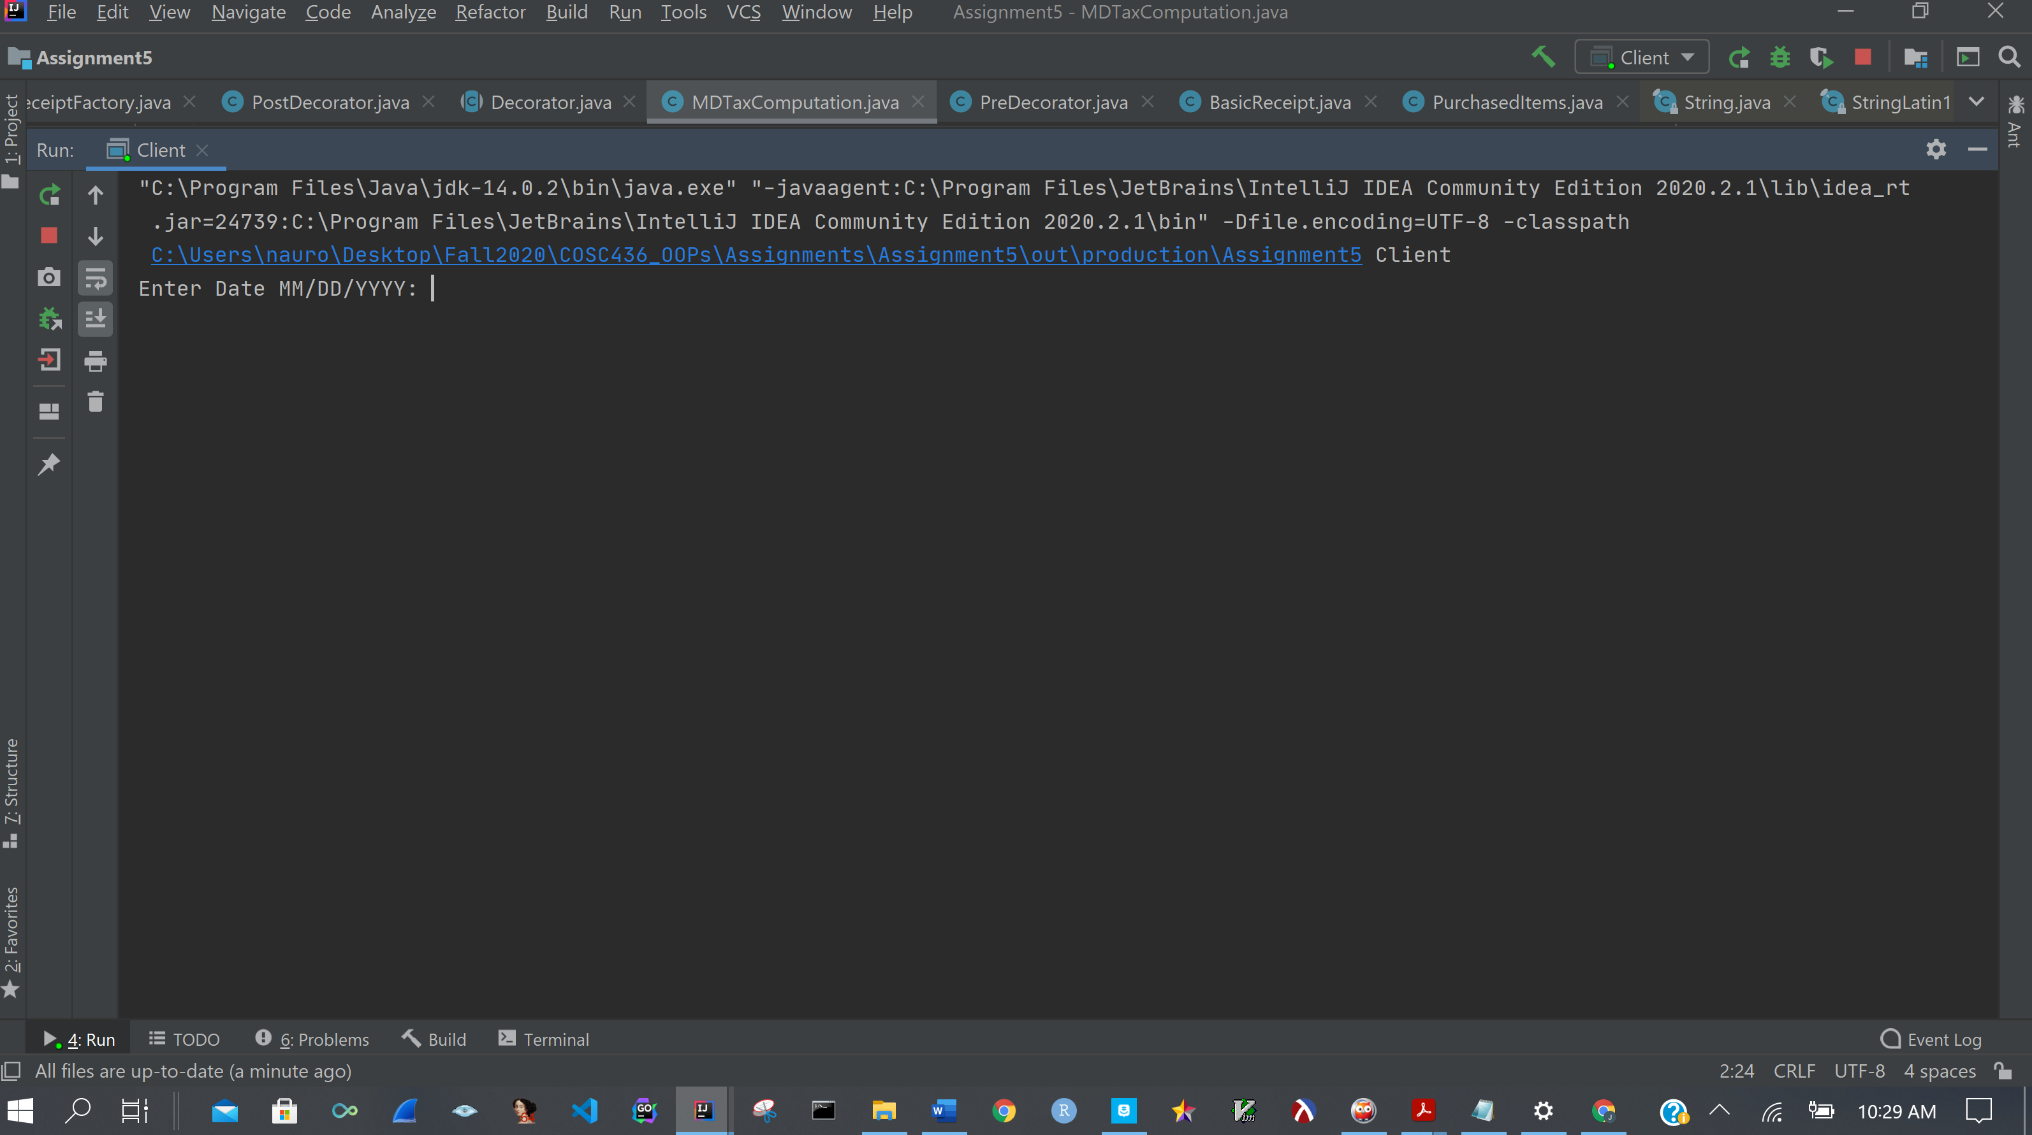

After a date is entered, a list of stores from different states appear. The user is prompted to select a store

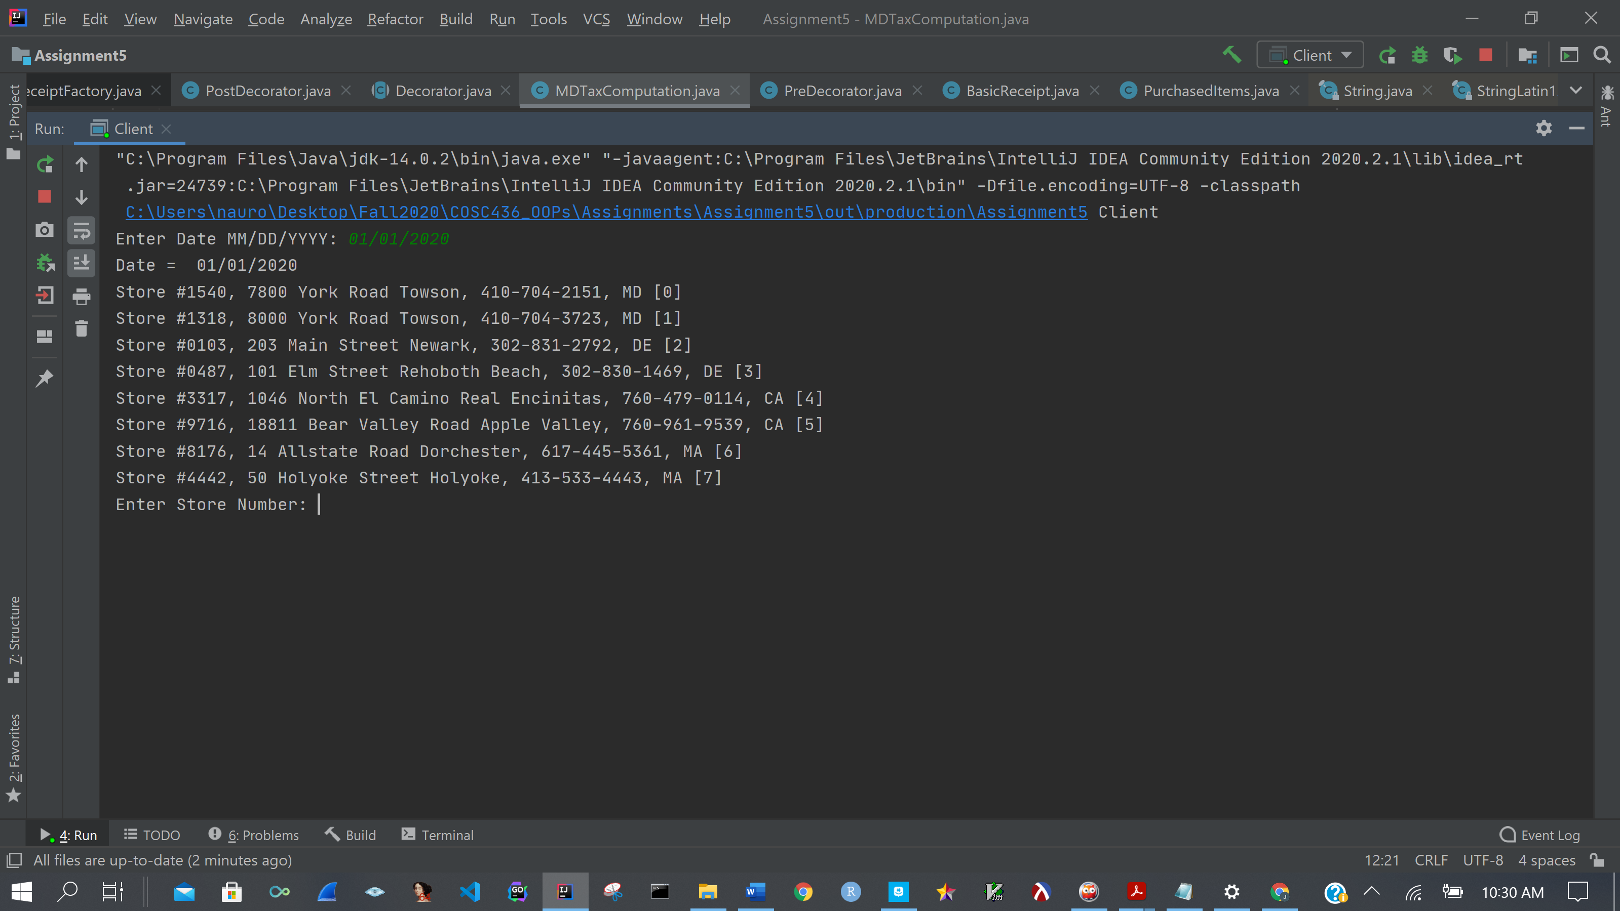

The user is then presented with a list of items and prompted if they wish to purchase that item

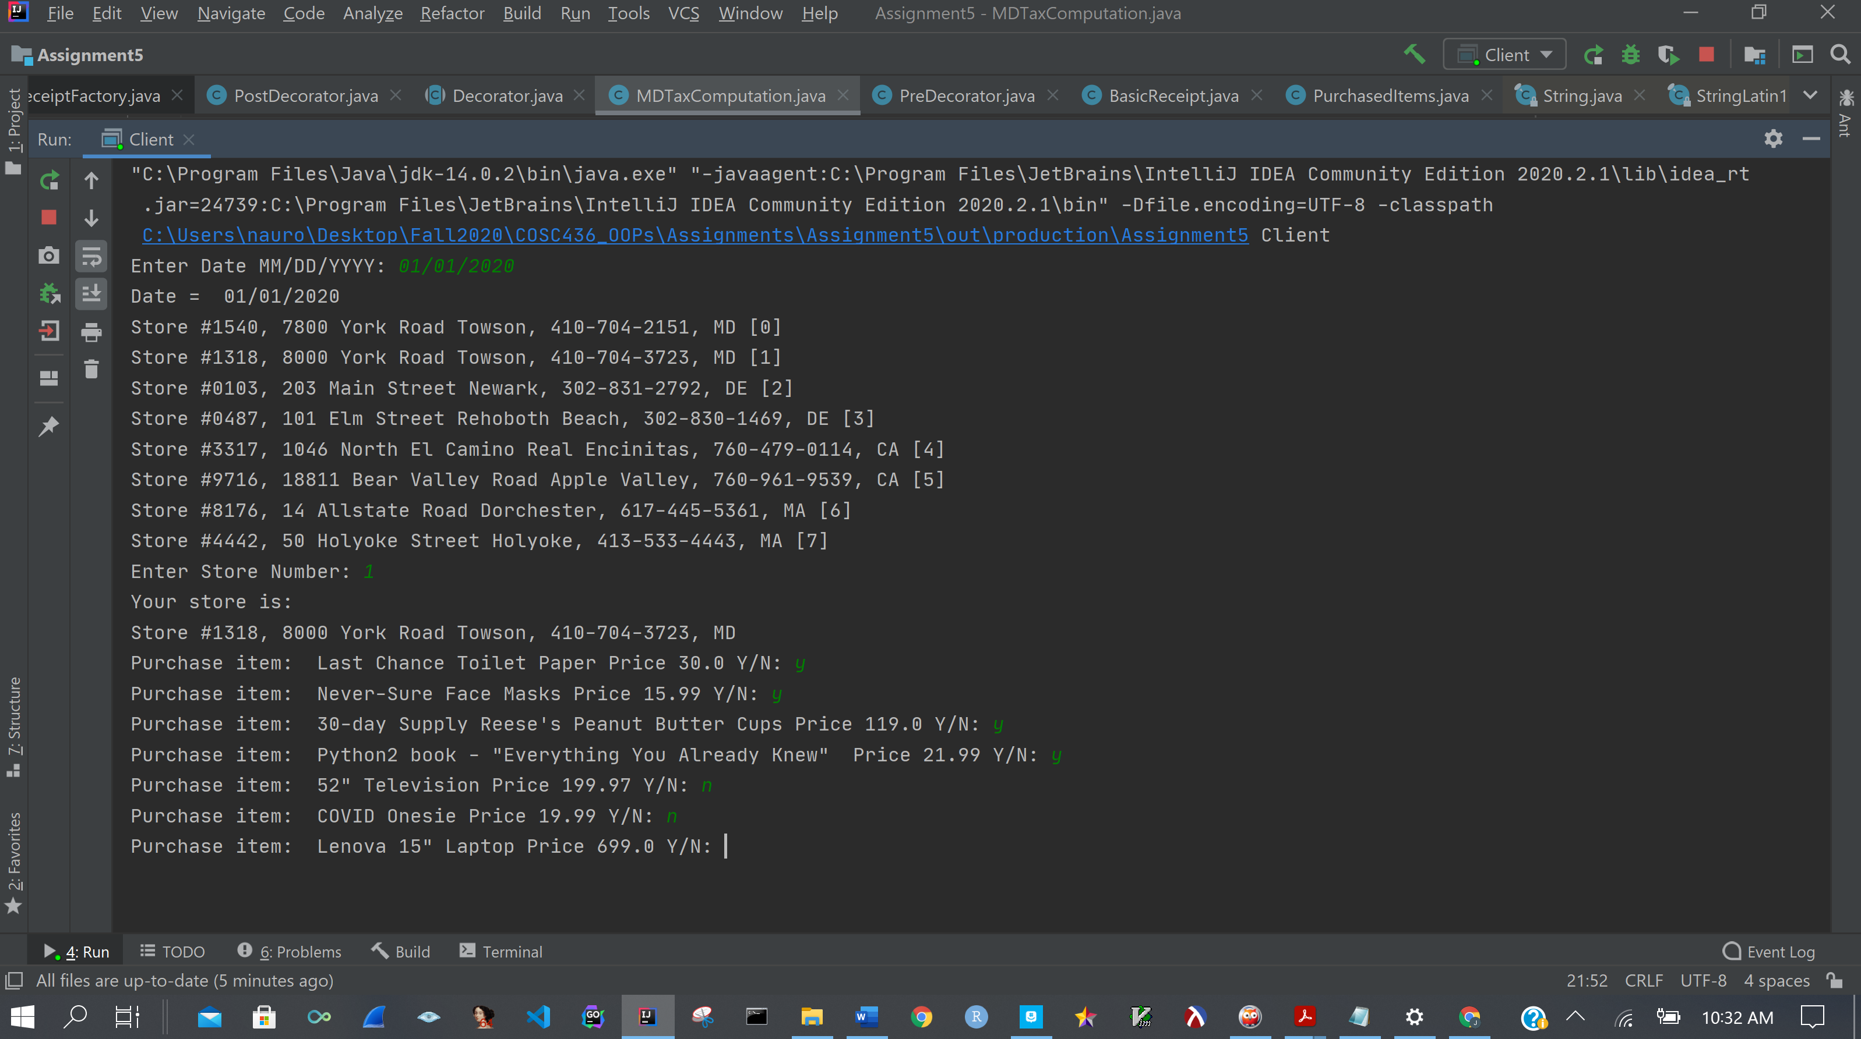

After the user has made their purchase selections, a receipt is produced

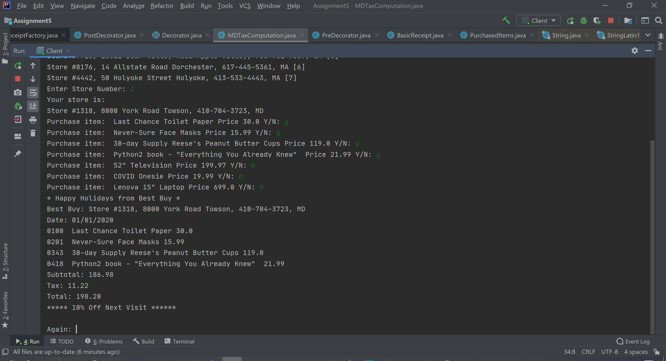

Since the subtotal was greater than or equal to $100.00, a coupon for 10% off next visit is added to receipt. The “Happy Holidays” banner is added to receipt. The store information and date are added to receipt. The appropriate tax for the state is computed and added to the receipt. The date is 1/1/2020 and it’s MD so it’s not a tax holiday. Now we’ll run it again, enter a date that falls within MD tax holiday, 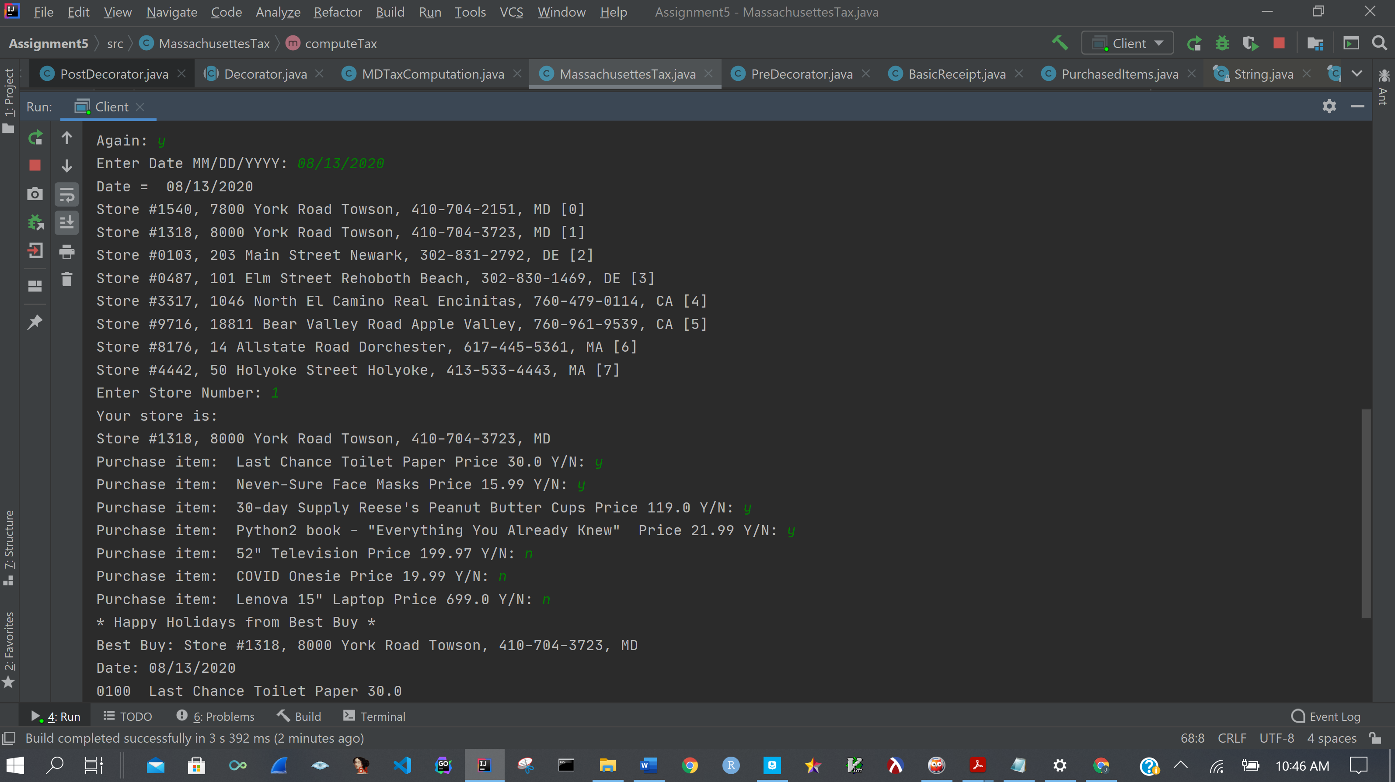purchase the same objects, and see the difference in receipts. The output is continued below

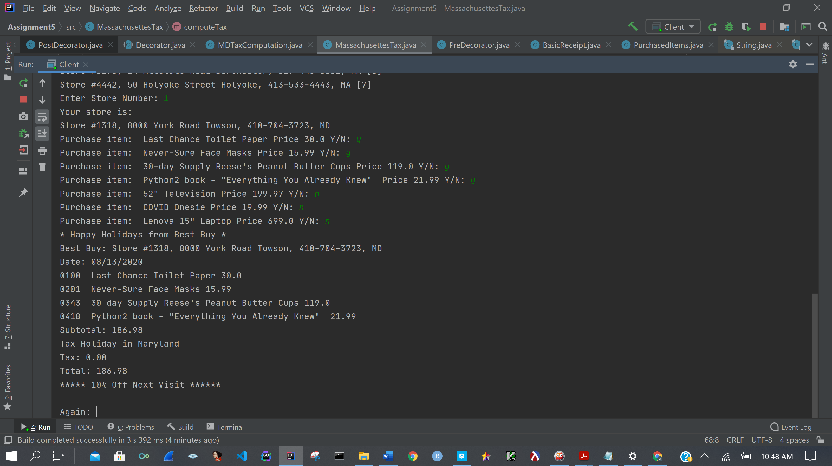

You can see that the receipt states that it’s a tax holiday in MD and has computed the appropriate tax. Now let’s look at rebates.

There is a rebate for item 1406 – which is the Lenova Laptop. We’re going shopping in California now on 1/1/2020

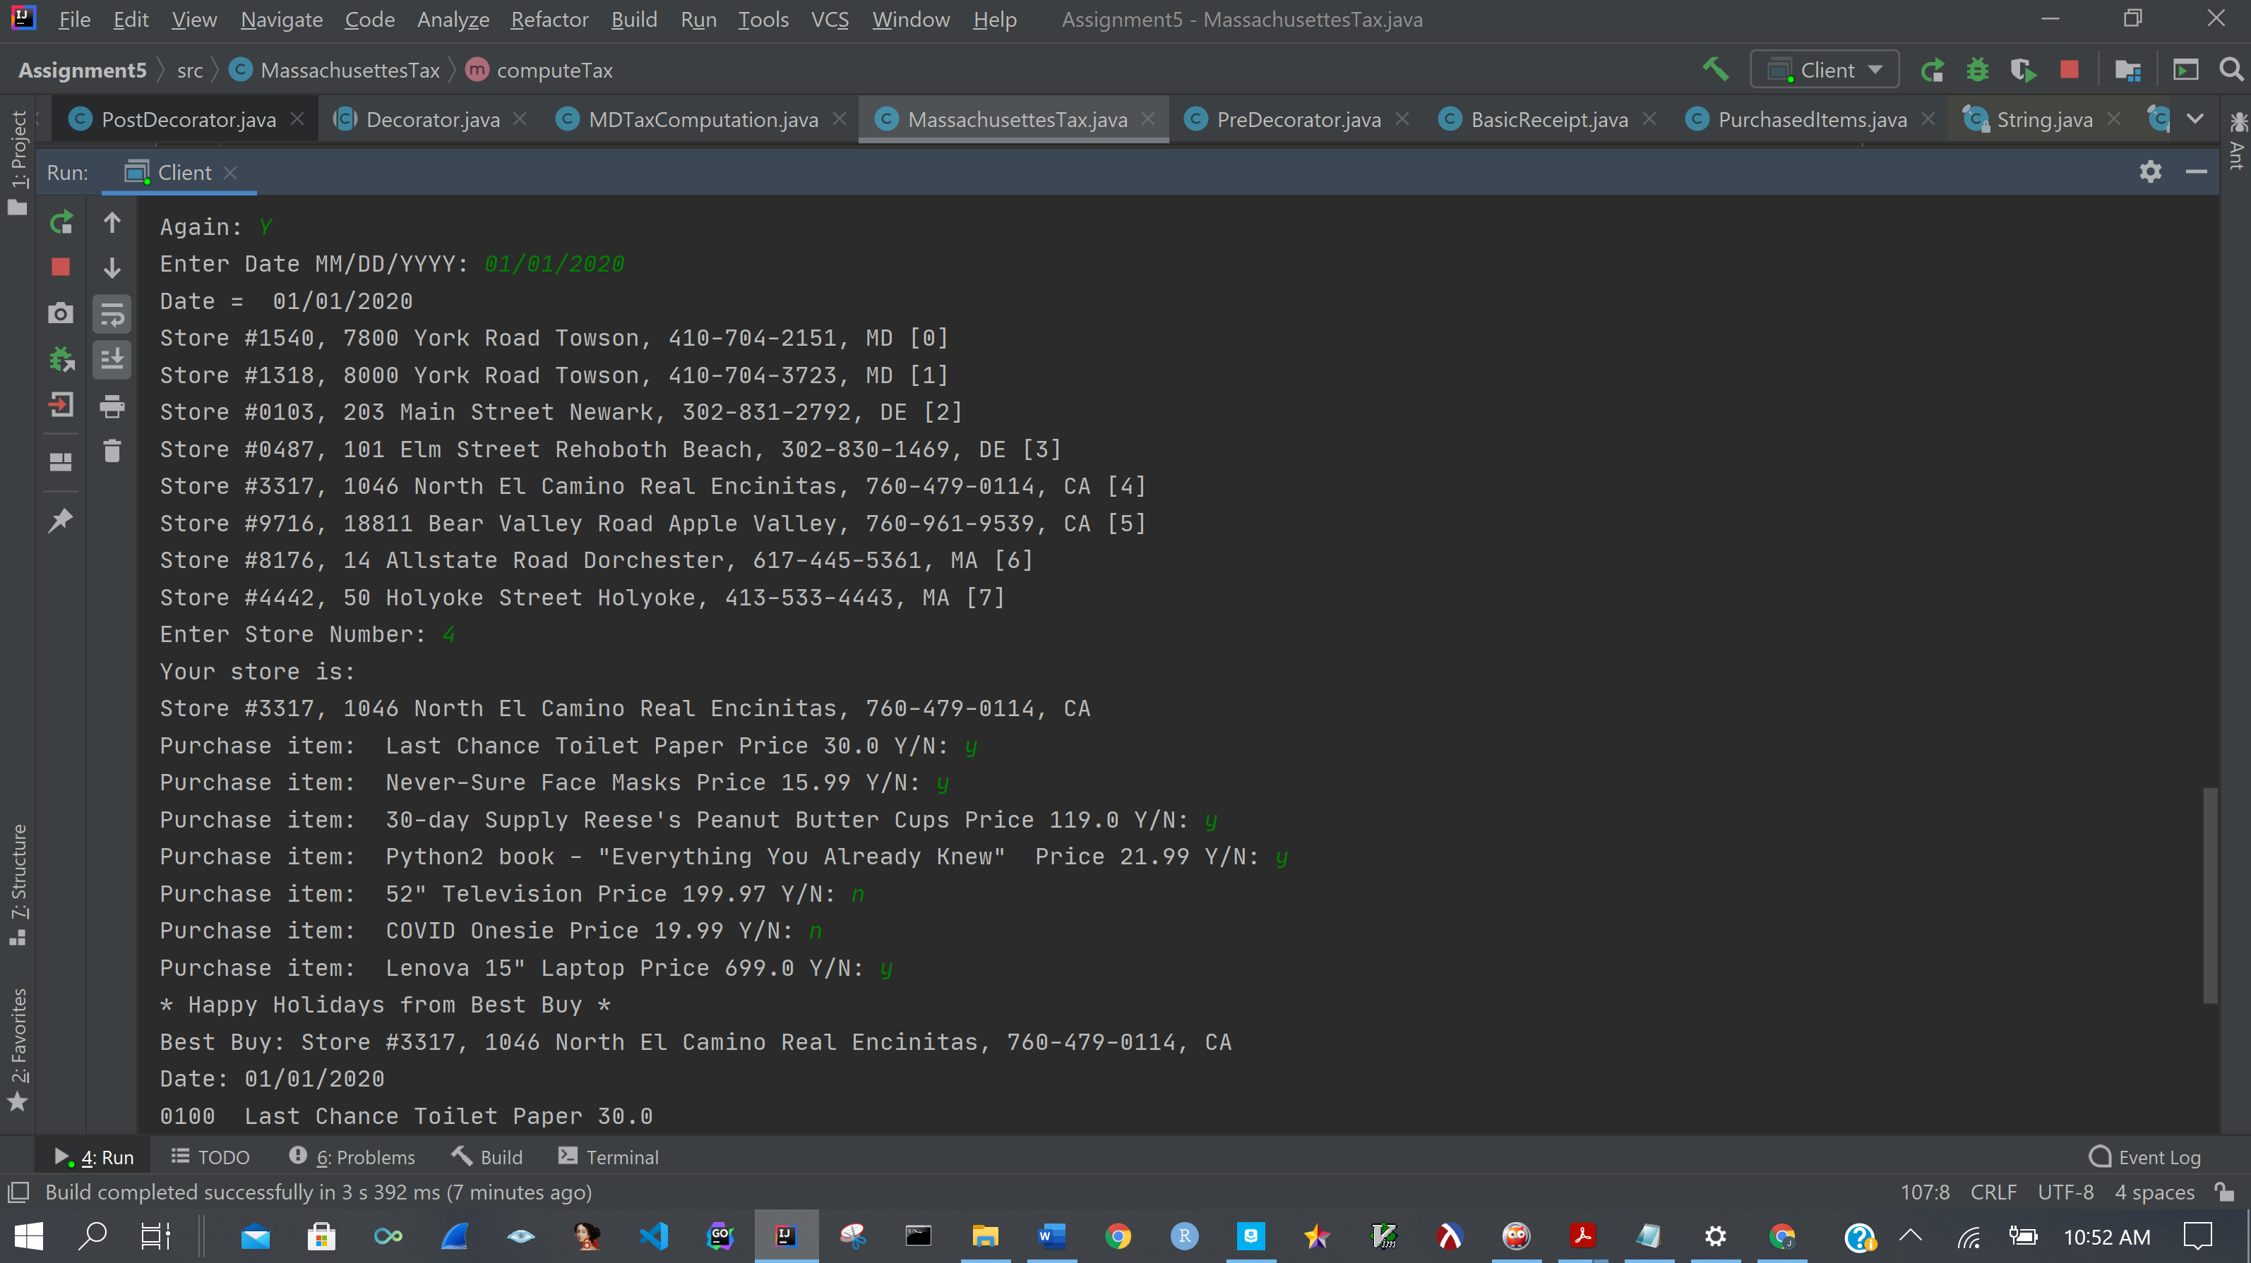

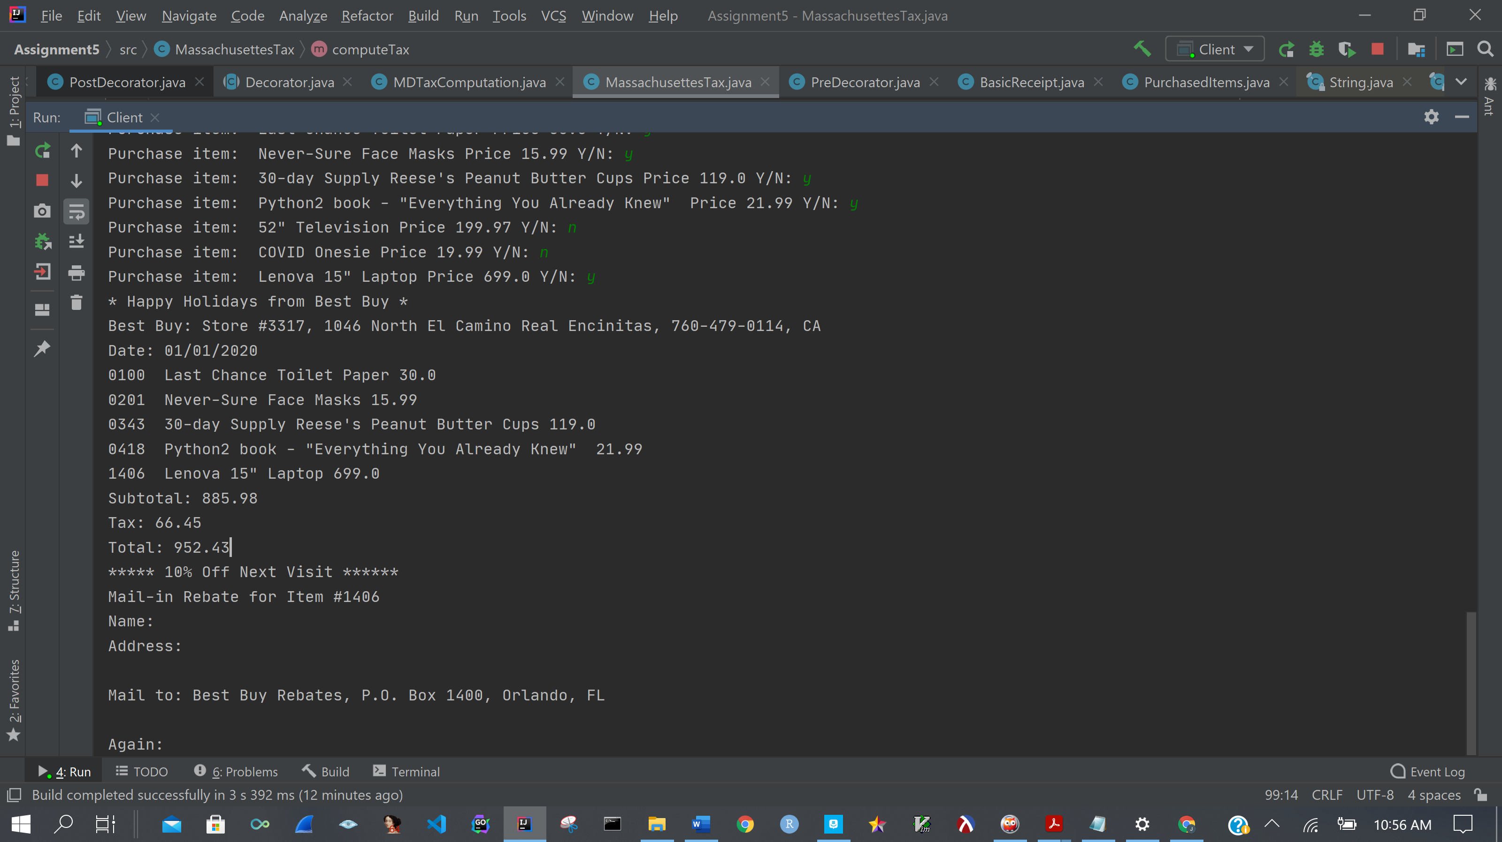

As you can see from the above receipt, the correct tax for California was computed, the rebate was added to the receipt, and, since the purchase was greater than $100.00, a coupon for 10% off next visit was added to receipt.

Now we’re going to make demonstrate Mass Tax computation object working

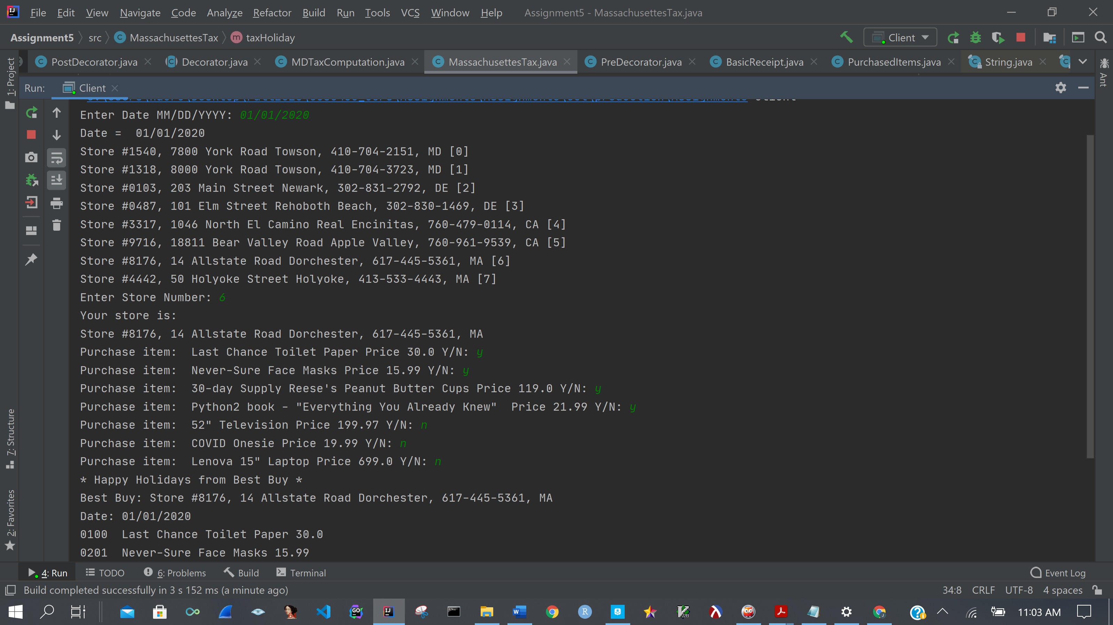

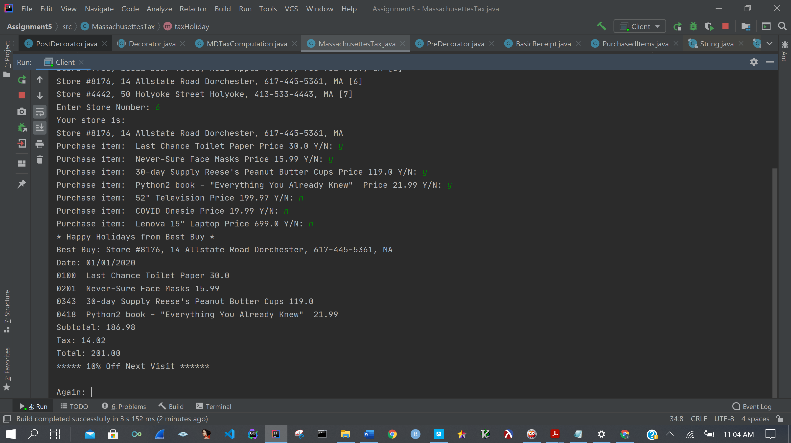

The tax was computed correctly and the appropriate decorators were added to receipt – store info, holiday banner, tax, and coupon

Now for Mass. A regular (no tax holiday) receipt

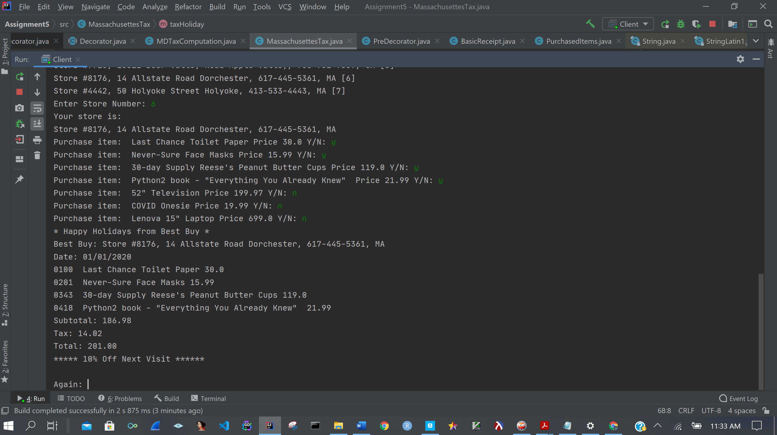

Now for the same store in Mass but during the tax holiday.

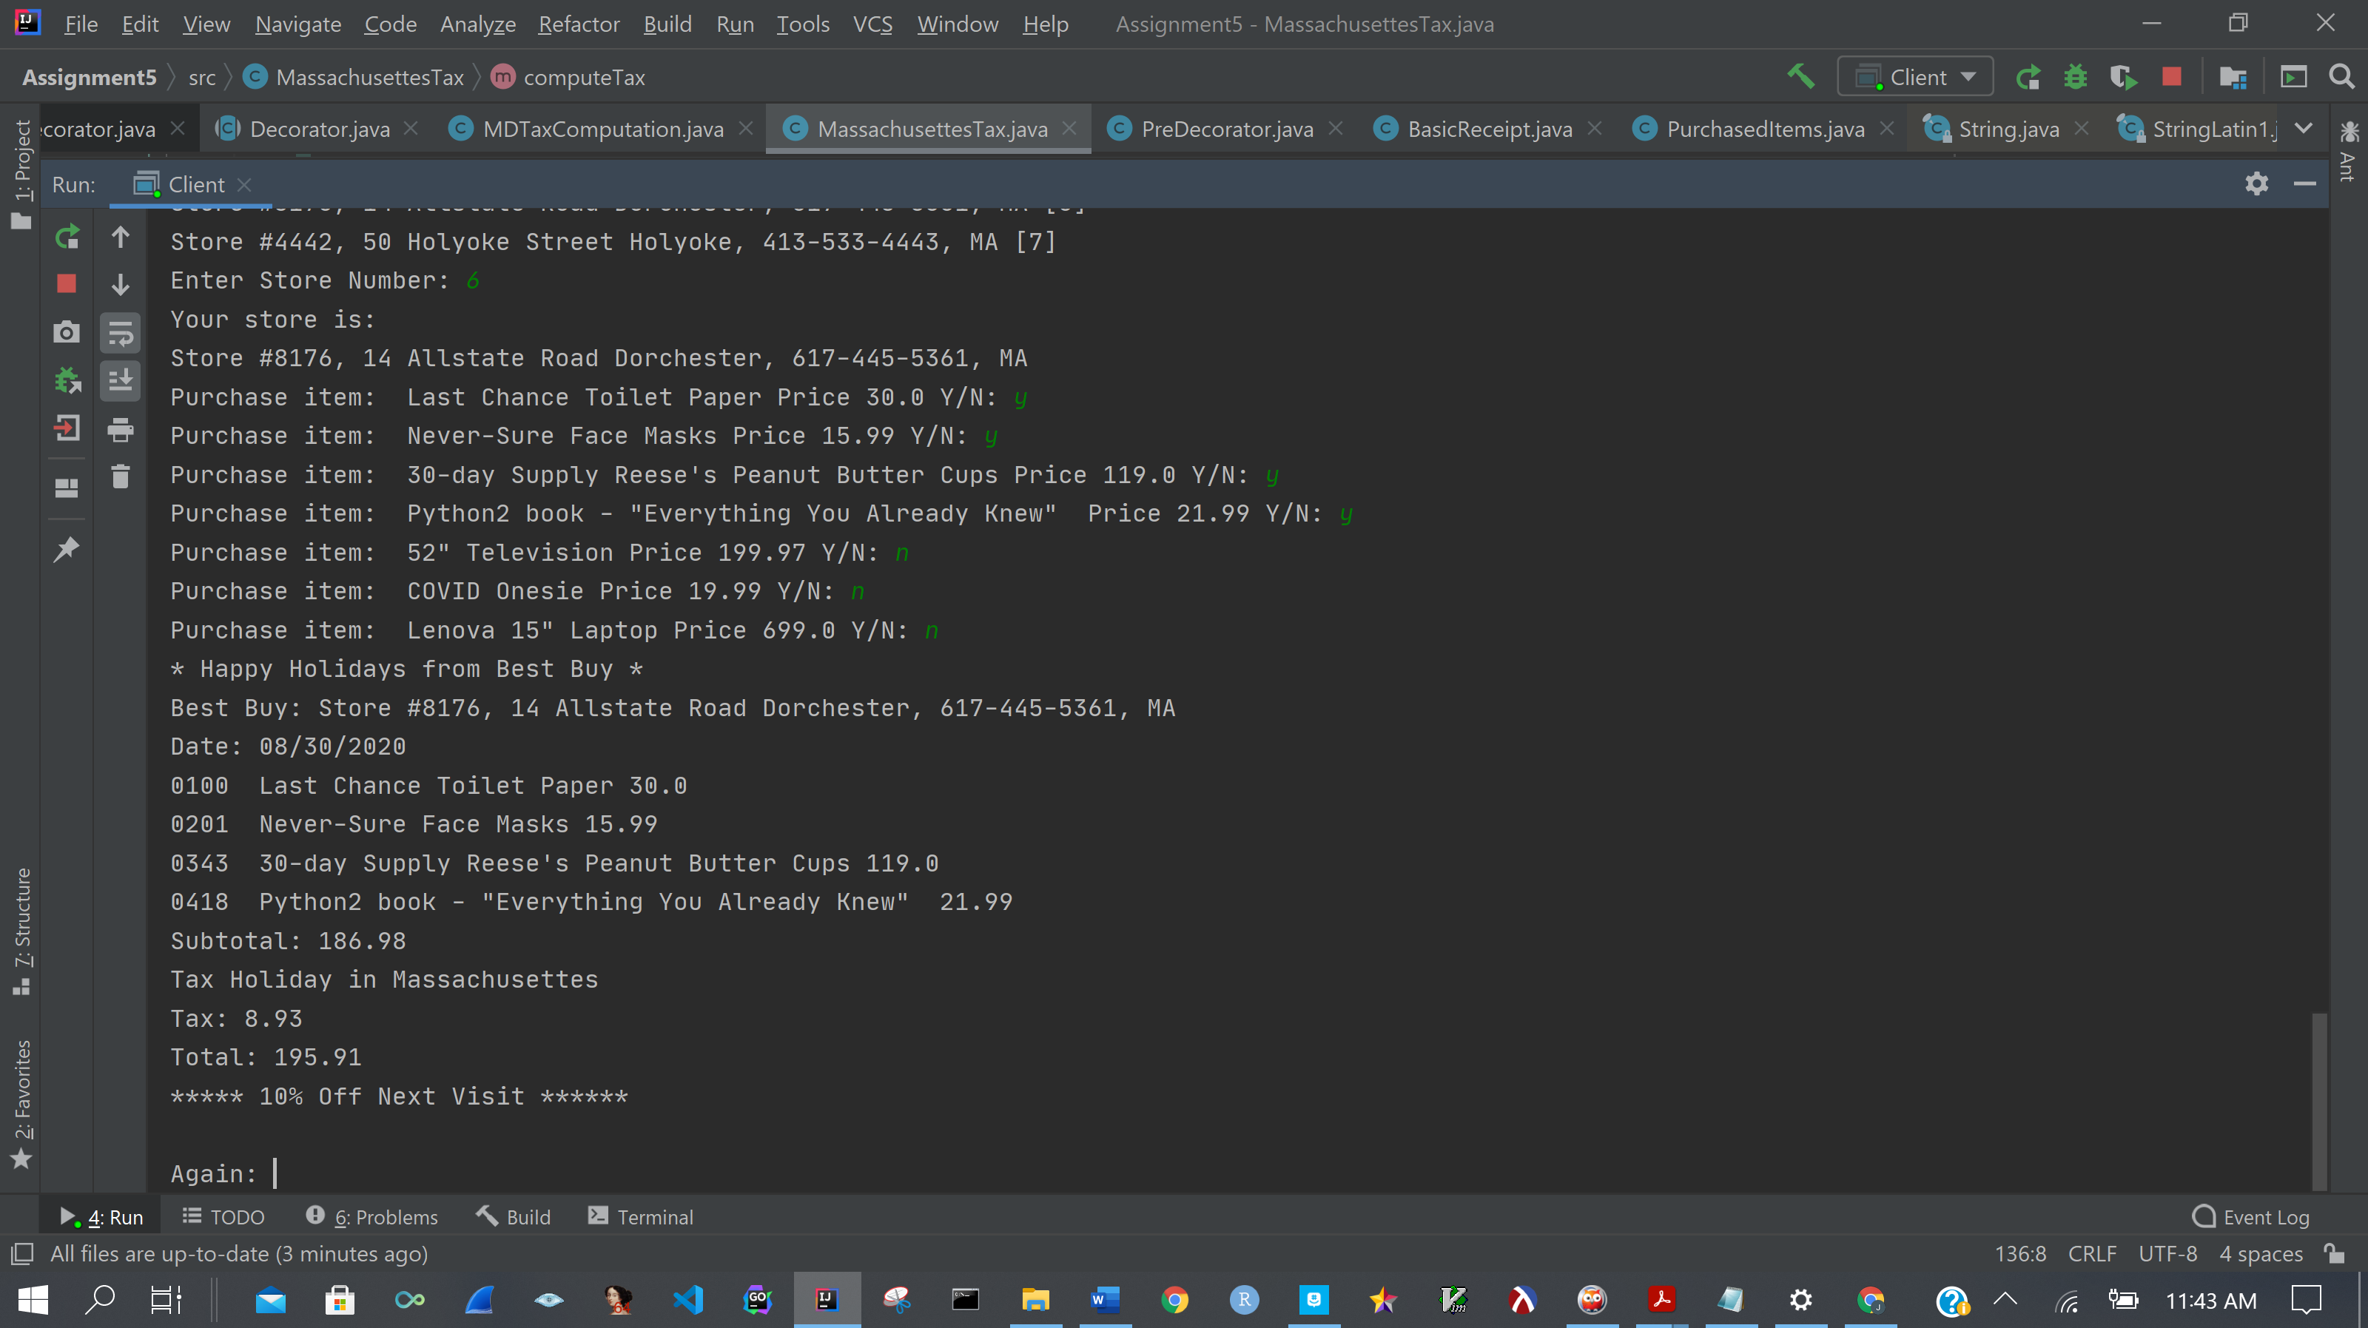

The tax during the tax holiday is different, although the same items were purchased. Unfortunately, the Reese’s Peanut butter cups are subject to tax.

Lastly (but the First State), we’ll look at Delaware.

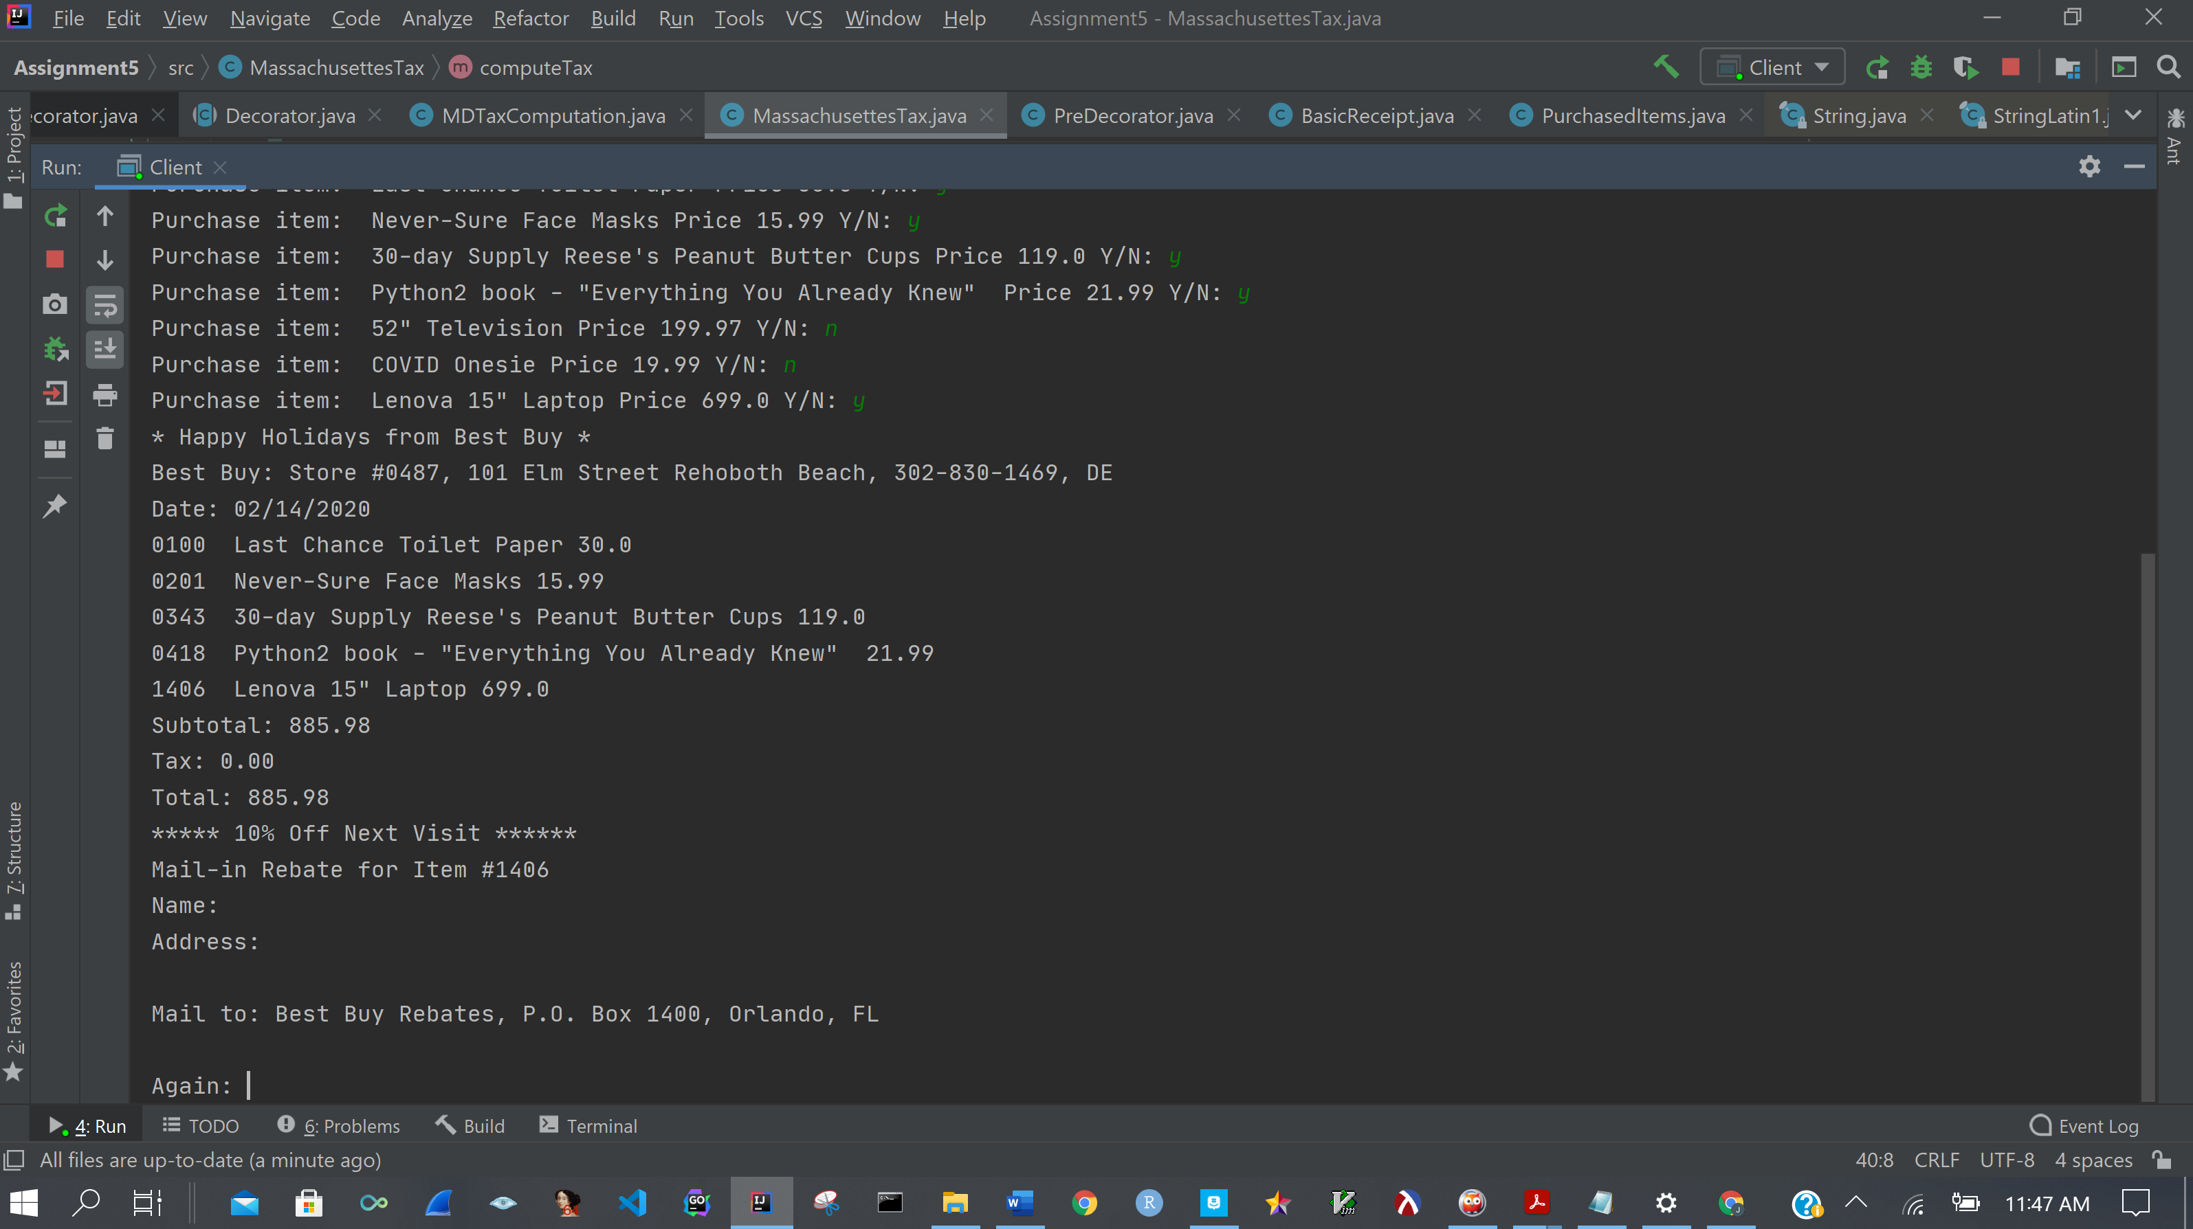

The date was added to the receipt. We purchased item 1406 (Lenova Laptop), so the rebate was added to receipt. The holiday banner and store info was added to receipt. The correct Tax computation object was used. The coupon for 10% off next visit was added as well since the total was >= $100.00